Hostel Like

Hostel Like offers rooms with free Wi-Fi and satellite TV in the historic centre of Sarajevo. It is set 500m from the vivid Baščaršija area and the City Hall. Free parking is provided.
Like Hostel serves continental breakfast and features a terrace and barbecue facilities. All rooms, including dormitories, come with their own bathroom that includes a shower.
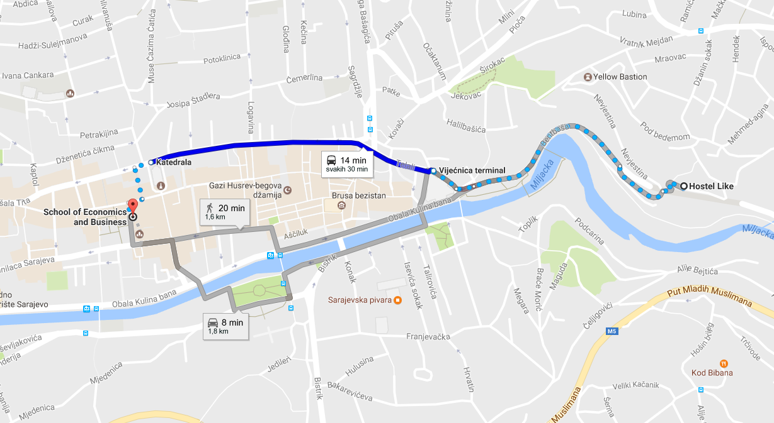
Bentbaša Promenade along River Miljacka is about a minute walk away, while the nearest grocery shops and restaurants can be reached in a 3-minute walk.

Accomodation type | Price per unit | 6 nights (Sunday – Saturday)
One bed | 10-15€ (depending of how many beds you want in room) | 60€ - 90€
One bed + Breakfast | 12 – 17€ (depending of how many beds you want in room) | 72€ - 102€

