Student Dormitory Centre Bjelave – Sarajevo

The public institution with basic activities of accommodation and providing food for students in Sarajevo. Dormitory Centre Bjelave provides accommodation and meals for about 2,000 students in the Student village Bjelave, and takes care of cultural entertainment and sports offer, educational and IT facilities. During the academic year, the Student Center Sarajevo carried out a number of useful and interesting contents such as various language courses and courses in the field of computer science, and great entertainment, cultural, tourist and sports activities.
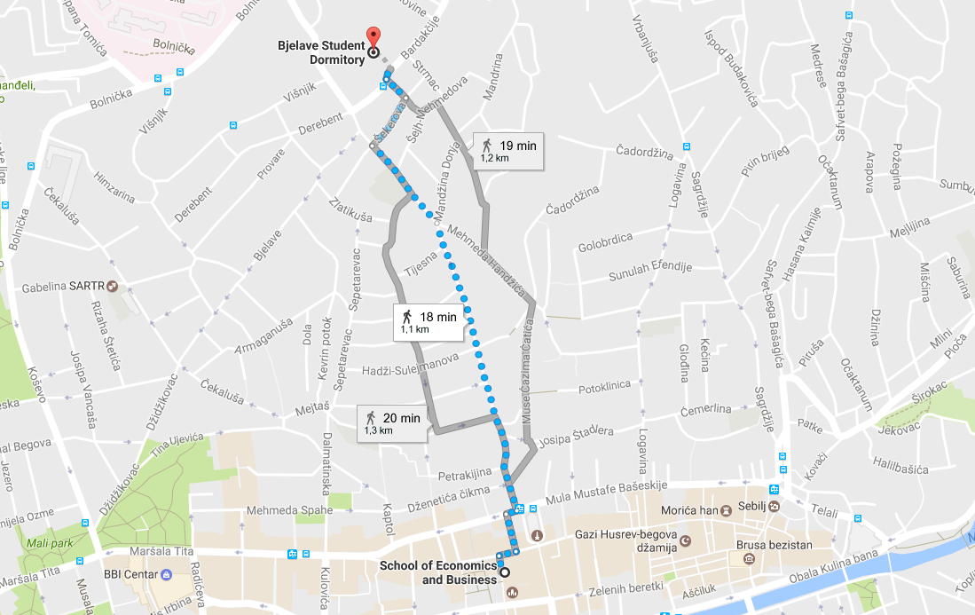

Accomodation:
Accomodation type | Price per unit | 6 nights (Sunday – Saturday)
One bed | 8€ | 48€
One bed + Breakfast | 10€ | 60€
One bed + Breakfast + Dinner | 12€ | 72€

