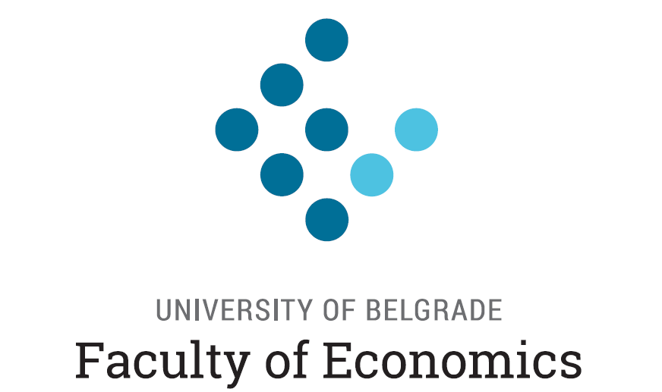

Regional Summer School for Young Economists
“Data Analysis for Public Policy”

Instructors: Merima Balavac, PhD; Marjan Petreski, PhD; Lazar Čolić, MSc

Location: Business Academy, 3rd Floor, Room 40, Skenderija 70, Sarajevo

Duration: July 09-13, 2019

Description: This course aims to examine the data currently used to evaluate public sector performance, with a focus on the art of analyzing and interpreting data for public policy purposes and of acquiring an empirical tools used in contemporary applied economics research. We will use these tools “first hand” within statistical programming package, such as STATA and R.

Training Agenda

Tuesday, July 09, 2019
09:30 – 10:00 | Registration
10:00 – 11:30 | Session 1 (Introduction to the classical linear regression model)
11:30 – 11:45 | Coffee break
11:45 – 13:15 | Session 2 (Assumptions underlying the classical linear regression model)
13:15 – 14:00 | Lunch*
14:00 – 15:30 | Session 3 (Introduction to STATA)

Wednesday, July 10, 2019
10:00 – 11:30 | Session 1 (Diagnostic testing)
11:30 – 11:45 | Coffee break
11:45 – 13:15 | Session 2 (Diagnostic testing)
13:15 – 14:00 | Lunch*
14:00 – 15:30 | Session 3 (Further hints in Stata / Application on micro data)
15:30 – 15:45 | Coffee break
15:45 – 17:00 | Session 4 (Dummy variables & interactions / Application of a Mincerian earnings function)

Thursday, July 11, 2019
09:00 – 10:30 | Session 1 (Selection / Heckman two-step method)
10:30 – 10:45 | Coffee break
10:45 – 12:15 | Session 2 (Repeated imputations / Application to wage imputation)
12:15 – 13:00 | Lunch*
13:00 – 14:30 | Session 3 (Quantile regression)
From 17:00 | Sarajevo City Tour (Meeting in front of hotel Art, Vladislava Skarića 3)

Friday, July 12, 2019
09:30 – 10:30 | Session 1 (Getting started with R)
10:30 – 10:45 | Coffee break
10:45 – 11:45 | Session 2 (Data management)
11:45 – 12:30 | Lunch*
12:30 – 13:30 | Session 3 (Programming with R)
20:00 – 22:00 | Gala Dinner, Restaurant Tavola, Maršala Tita 50, Sarajevo

Saturday, July 13, 2019
09:00 – 10:30 | Session 1 (Fundamentals of data analysis)
10:30 – 10:45 | Coffee break
10:45 – 11:45 | Session 2 (Linear models)
11:45 – 12:30 | Lunch (for those who are traveling lunch box will be provided)

Note: * Lunch will be provided to all school participants.

