**NEWSLETTER 1: FIRST NETWORLD CHAPTER AT SEBS**

Starting from January 01st, 2017, when the School of Economics of Business University of Sarajevo (SEBS), has assumed the partner role in the implementation of the project **NETWORLD - NETWORKING IN PRESERVING THE FIRST WORLD WAR MULTICULTURAL HERITAGE IN THE DANUBE COUNTRIES** supported and financed by the EU Interreg Danube Transnational Programme, Call 1, several activities have been successfully launched and finalized:

* SEBS's NETWORLD team attended the kick-off project meeting held in Kobarid, Slovenia in February. The meeting was rather successful given the fact that partners had the opportunity to meet their colleagues and discuss in details activities and priorities to be implemented in the following period.
* SEBS's NETWORLD team organized the first project press conference in May, 2017. The goal of the conference was to introduce the BH public with the idea and goals of the NETWORLD project. Several news portals have reported about the event.
* SEBS's team initiated contact with First Level Control (Ministry of Finance B&H) and Directorate for European Integration in order to introduce the team and obtain advice regarding reporting procedures.
* SEBS's NETWORLD Project Coordinator attended the 1st Project Partner Meeting and  International Conference on Protection Measures of the First World War Heritage and   
  held in Krems, Austria. Both meeting and conference served as a great opportunity to discuss the current project activties a resolve some of the ongoing issues.
* SEBS's NETWORLD team, supported by external expert, commenced the implementation of the activities within the Work Package 3 - Database and Strategy Development. As foreseen by the project activities, SEBS and other partners in their respective countries have started with the process of in-depth interviewing the stakeholders and experts in WW1 heritage protection, conservation and presentation. Based on the performed interviews the database that gathers the historical and cultural evidences on WW1 events and places (battlefields, prisoner’s camps, memorial parks, museums) will be built.

More information about the Project activties, results and partners available at the project's webpage www.interreg-danube.eu/networld.

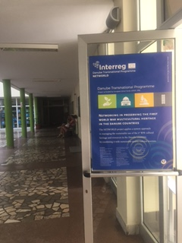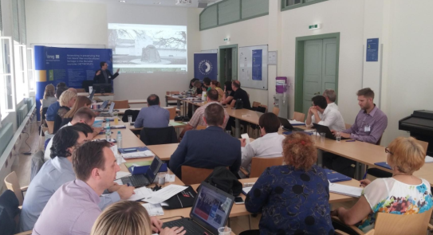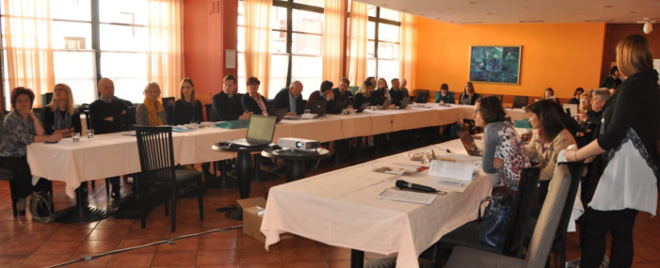

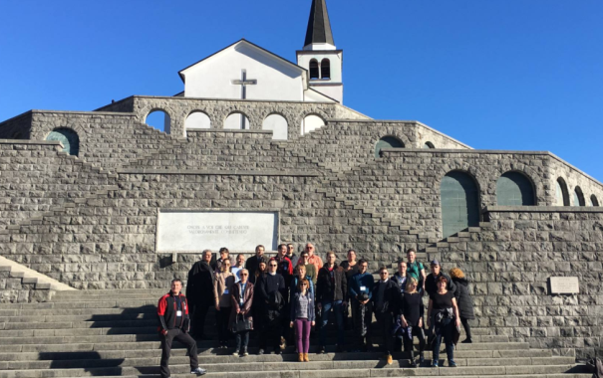NETWORLD Kick-off Meeting in Krems

NETWORLD visibility at SEBS

1st PP Meeting in Krems

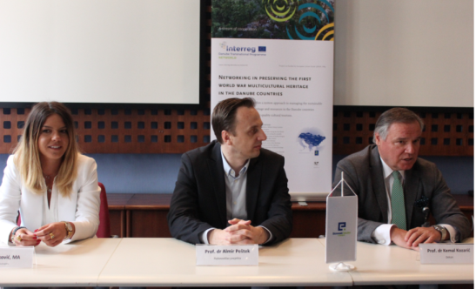



**NETWORLD partners visiting Soča Valley**