

**Paper Title [Times New Roman 14, bold, centered, Title Case, Maximum 130 characters]**

Author Name1 [Times New Roman, 12-point, bold, centred]

*Author Institution [12-point, italic, centred]*

e-mail

Author Name2 [Times New Roman, 12-point, bold, centred]

*Author Institution [12-point, italic, centred]*

e-mail

# Abstract [Times New Roman, 12-point, bold, left]

*This template serves as a guide for formatting your paper. Save it to your computer and insert your text while preserving the designated styles and formatting. The different elements of your paper (title, abstract, keywords, sections, text, etc.) are pre-defined in the style sheet, as shown in the examples within this document. [Times New Roman, 12-point, italic, justified alignment, Line spacing: Single].*

**Keywords:** Keywords1, KeyWords2[Times New Roman, left alignment].

# Section [Times New Roman, 12-point, bold, left alignment and capitalize the first letter]

All pages size should be A4 (21 x 29,7cm). The top, bottom, right, and left margins should be 2,54 cm. All the text must be in one column and Times New Roman font, including figures and tables, with 1.5 line spaced. Please use the normal style for this paragraph. [Times New Roman, 12 point, normal, justified alignment, Line spacing: 1.5]

Please make sure that if you use charts, they are centered as shown in the example. The title below the image should be formatted as shown below.

*Figure 1. Figure Title [Times New Roman, 12, italic, left alignment and capitalize]*

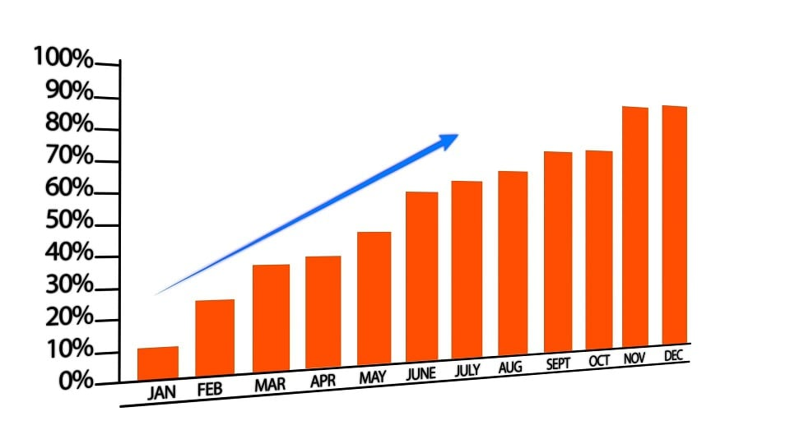

*Source: [Times New Roman, 12-point, left]*

Please ensure that if you use tables, they are centered as shown in the example. The title below the table should be formatted as shown below.

*Table 1. Table Title [Times New Roman, 12, italic, left alignment and capitalize]*

|  |  |  |  |
| --- | --- | --- | --- |
| Example | Title |  |  |
|  |  |  |  |
|  |  |  |  |

*Source: [Times New Roman, 12-point, left]*

## Subsection [Times New Roman, 12, bold, left alignment and capitalize the first letter]

The text included in the sections or subsections must begin one line after the section or subsection title. Please use one hard tabs and limit the use of hard returns to one return at the end of a paragraph. Please, do not number manually the sections and subsections; the template will do it automatically.

**REFERENCES [Times New Roman, 12-point, bold, left alignment]**

Follow reference style APA 6ed. Official website: <http://www.apastyle.org/>

Reference: Times New Roman, 12-point, left alignment, upper and lower case

Printed book: Author. (Year). *Title*. Edition. Volume. Place of publication: Publisher.

Printed scientific journal article: Author. (Year). Title. *Journal title, Volume*(Issue), Pages. Doi

Website: Author. (Year, Last Update Date). Title. *Series Title.* Retrieved access date, from URL